Sales Performance & Customer Analytics Report
Customer Purchasing Patterns, Top Customer Identification & Retention Analysis
Prepared: July 2026 | Data period: Jan 1 - Apr 9, 2024 | Sources: sales_data.csv, customer_churn.csv

1. Problem Definition
The business needs a clear view of who its customers are, how much they are worth, which products and regions drive revenue, and whether purchasing activity is linked to customer retention. This report analyzes 100 sales transactions recorded between January and April 2024 alongside a 500-record customer churn dataset to answer four questions:
- Who are the highest-value customers, and what is their estimated lifetime value?
- Which products and regions generate the most revenue, and how does revenue trend month over month?
- What is the customer retention rate, and does it vary by contract type?
- What actions should the business take based on these findings?

2. Data Collection & Preparation
Two files were used: a transactional sales extract (100 rows: Date, Product, Quantity, Price, Customer ID, Region, Total Sales) and a customer churn file (500 rows: Tenure, Monthly Charges, Total Charges, Contract, Payment Method, Paperless Billing, Senior Citizen flag, Churn flag).
Data quality checks found no missing values and no duplicate rows in either file, though a defensive cleaning step (median-fill for numeric columns, mode-fill for categorical columns) was included in the pipeline for robustness against future data refreshes.
The two files use different customer ID formats (e.g. "CUST001" vs "C00001"), but both encode the same underlying numeric key. Extracting that key allowed the two datasets to be merged, revealing that the 100 transacting customers are a subset of the full 500-customer base. Additional calculated fields were engineered: transaction month, weekday, and a validation column confirming Total Sales equals Quantity times Price for all records.

3. Exploratory Data Analysis
Across the observed period the business recorded ₹12,365,048 in total revenue from 100 orders, an average order value of approximately ₹123,650. Revenue was recorded across 5 product lines (Laptop, Tablet, Phone, Headphones, Monitor) and 4 regions (North, South, East, West).

4. Customer Analysis: Top Customers & Lifetime Value
The table below shows the five highest-spending customers by total transaction value:
Rank | Customer ID | Total Revenue
1 | CUST016 | 373,932
2 | CUST007 | 363,870
3 | CUST083 | 350,888
4 | CUST073 | 349,510
5 | CUST020 | 333,992

Because each customer in the sales extract completed a single recorded transaction, lifetime value was estimated by combining transaction revenue with churn-file tenure and monthly charges (Estimated CLV = Monthly Charges x Tenure) for the matched customers. This gives a directional CLV estimate until multi-purchase history is captured.
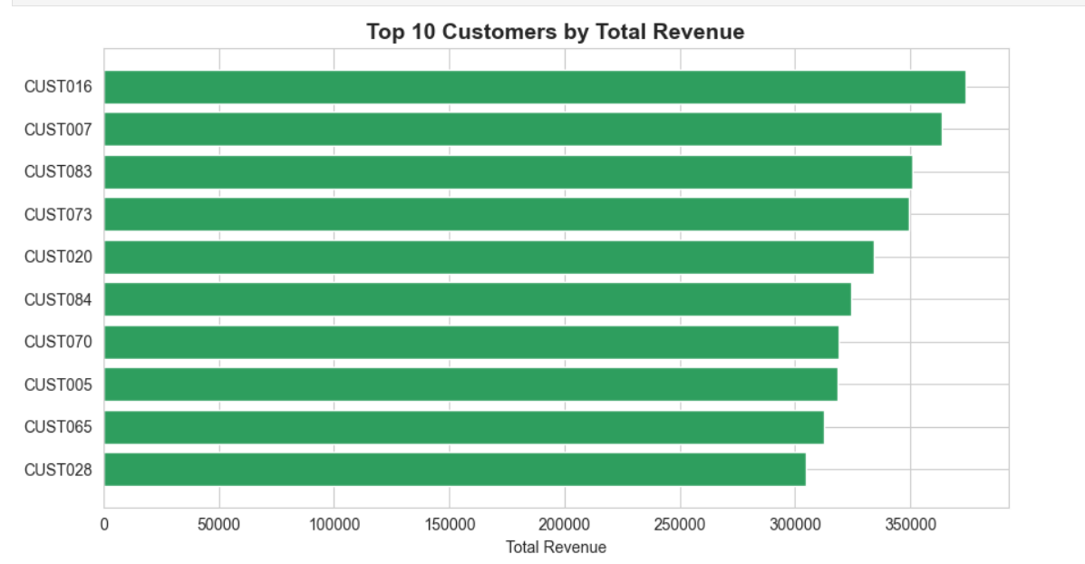

Figure 1 .top 10 customers by total Revenue

5. Regional Distribution
Revenue by region, highest to lowest:
Region | Total Revenue | Share of Total
North | 3,983,635 | 32.2%
South | 3,737,852 | 30.2%
East | 2,519,639 | 20.4%
West | 2,123,922 | 17.2%

North and South together generate over 62% of total revenue, while West is the weakest-performing region at 17.2% of revenue.

6. Monthly Sales Trend & Best-Selling Products
Monthly revenue peaked in March 2024 and dipped sharply in the partial data available for April:
Month | Total Revenue
Jan 2024 | 4,120,524
Feb 2024 | 2,656,050
Mar 2024 | 4,485,006
Apr 2024 (partial) | 1,103,468

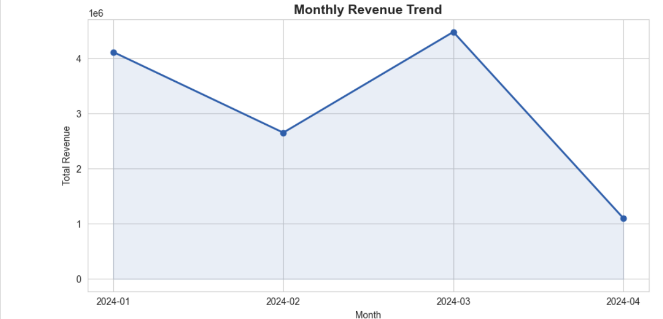
Figure 2. Monthly revenue trend, January-April 2024.
Laptops are the clear best-selling product line by revenue (₹3,889,210), followed by Tablets (₹2,884,340) and Phones (₹2,859,394). Headphones and Monitors trail well behind, each contributing roughly a third of Laptop revenue.
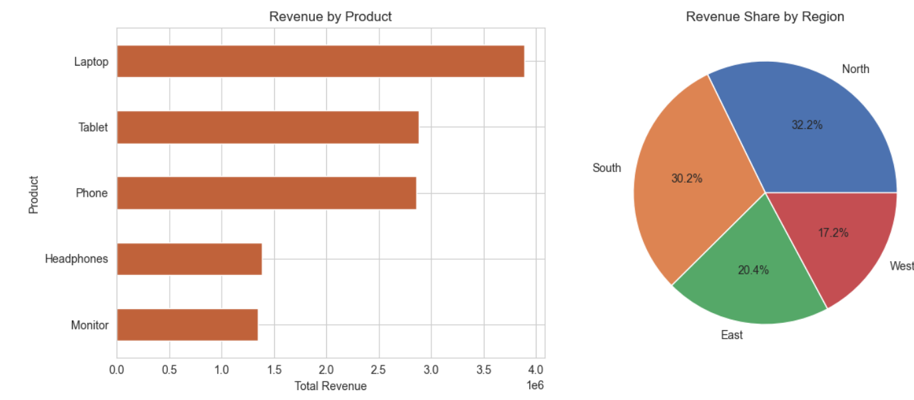

Figure 3. Revenue by product (left) and revenue share by region (right).

7. Pivot Analysis & Cross-Selling Signals
A Region x Product pivot table highlights where each product performs best, useful for regional inventory and merchandising decisions:

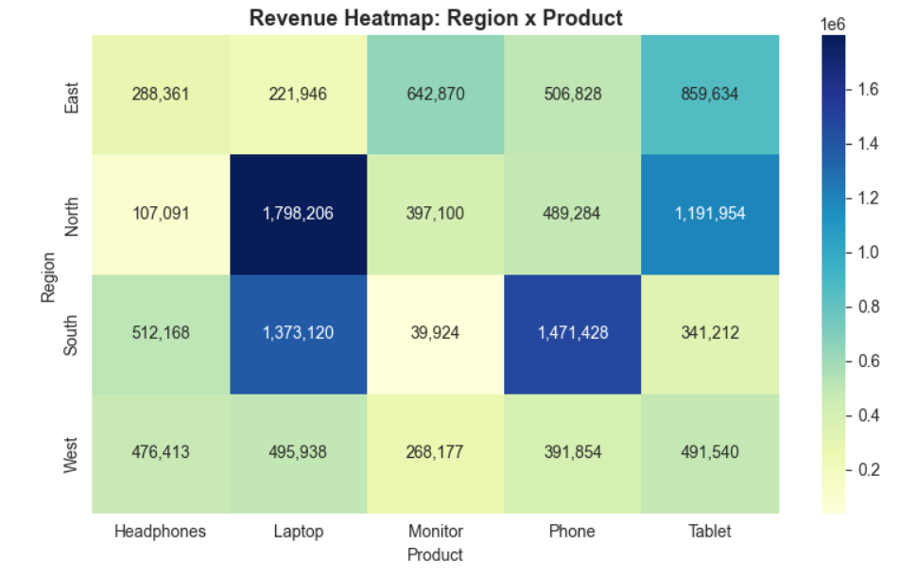
Figure 4. Revenue heatmap across Region and Product combinations.
Because the sales extract contains one transaction per customer, classic basket-level cross-selling cannot be measured directly. As a proxy, average spend and product mix were compared across contract types (from the merged churn data), which is a reasonable starting point for targeted upsell offers once repeat-purchase data becomes available.

8. Retention Rate Analysis
Using the full churn file, overall customer retention stands at 89.4% (a 10.6% churn rate). Among the subset of 100 customers who also appear in the sales extract, retention is slightly higher at 90.0%, suggesting that customers who transact at least once may be marginally less likely to churn.
Retention varies substantially by contract type among transacting customers:
Contract Type | Churn Rate | Avg. Order Value
Month-to-month | 17.1% | 107,608
Two year | 10.3% | 116,641
One year | 2.8% | 144,894

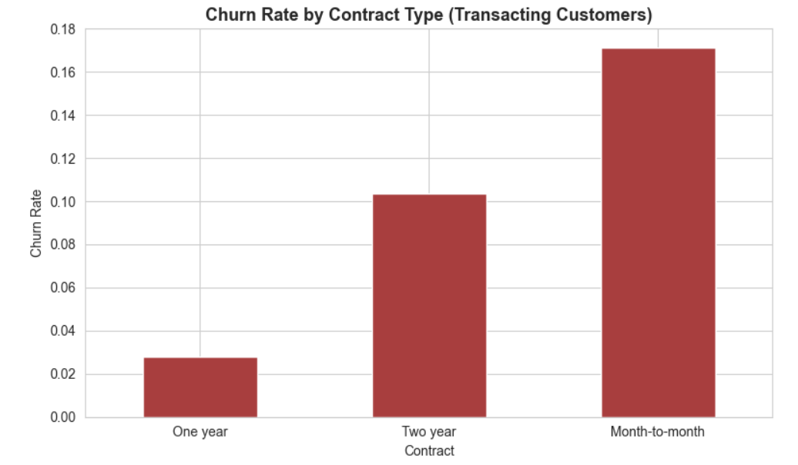
Figure 5. Churn rate by contract type among transacting customers.

Month-to-month customers churn at more than six times the rate of one-year contract customers, despite spending the least per order on average. One-year contract customers both spend the most per order and churn the least, making them the most valuable segment to protect and replicate.

9. Business Recommendations
- Protect and grow top accounts: assign dedicated account management to the top 10 customers, who together account for a disproportionate share of total revenue.
- Push month-to-month customers toward annual contracts: offer a modest discount or loyalty bundle to convert this highest-churn segment, since one-year contract holders both spend more and churn far less.
- Rebalance regional investment: sustain marketing spend in North and South, while running a targeted acquisition or promotional campaign in West, the weakest region.
- Double down on Laptops: prioritize inventory and promotional budget on the top-revenue product line, and consider bundling Monitors and Headphones with Laptop purchases to lift their comparatively low sales.
- Investigate the April dip: confirm whether the drop in April 2024 revenue reflects a partial month of data or a genuine seasonal or operational issue before adjusting forecasts.
- Improve data capture: log repeat purchases per customer going forward; this single change would unlock true basket-level cross-sell analysis and a much more accurate lifetime value model.

10. Executive Summary
Between January and April 2024 the business generated ₹12.37M in revenue from 100 transactions, led by Laptop sales and concentrated in the North and South regions. A small group of top customers drives a disproportionate share of revenue, and linking sales to churn records shows that contract type is a strong predictor of both spend and retention: one-year contract customers spend the most and churn the least, while month-to-month customers are the highest-risk, lowest-order-value segment. The clearest near-term levers are converting month-to-month customers to annual contracts, investing further in the North/South regions and the Laptop category, and closing the data gap that currently limits cross-sell analysis to a single transaction per customer.

